**Archery based castle survival game.**

Developer:Weifeng Huang, Jing Zheng

Gameplay:

Use full 3D motion w/ HTC Vive and controllers, the player can experience an archery based castle game. The two motion controllers are used to aim and shot a bow, player need to defeat different enemy models to protect the castle. The accuracy of shooting will affect the utility (ex. a headshot will kill level2 enemy in one shot). In addition, aimed shots at targets like oil can, balloon will activate traps/bonus.

Player Mode:

Single Player

Player Tools:

**Longbow:** Default

* *Headshot = 2 Regular Kills*

**Staff:** Activate after 150 points

* *Staff attack = 5 Regular Kills*

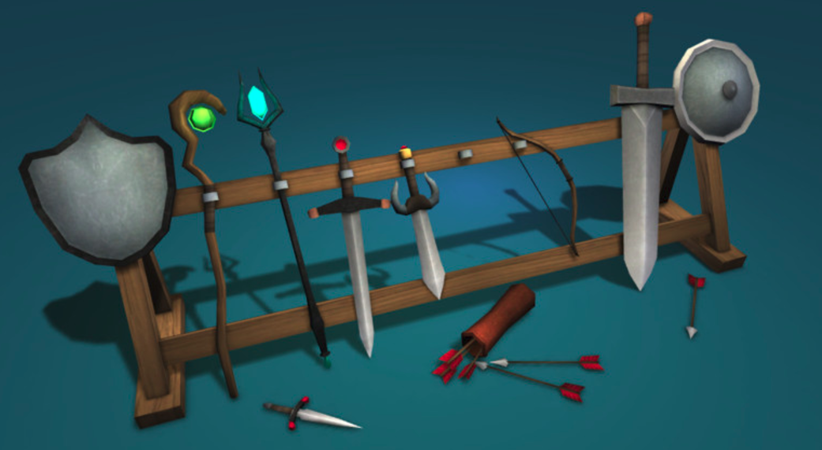

Enemy: *attacks castle, emits point particle after killed.*

**Level 1:** 1 regular kills (10 points), 1 headshot (30 points)

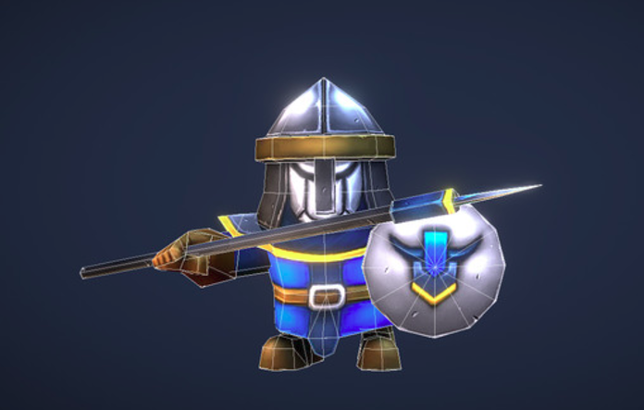

**Level 2:** 2 regular kills (20 points), 1 headshot (30 points)

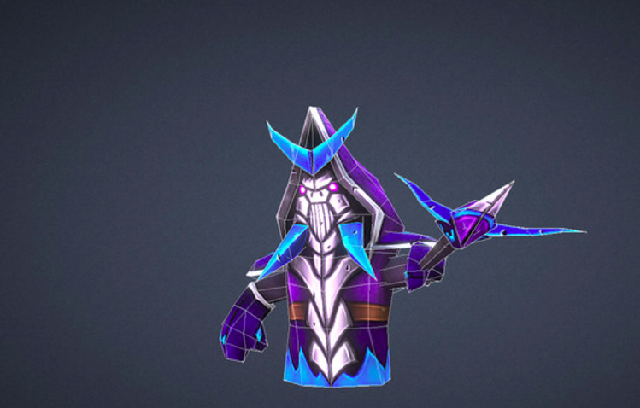

**Level 3:** 4 regular kills (40 points), 2 headshot (50 points)

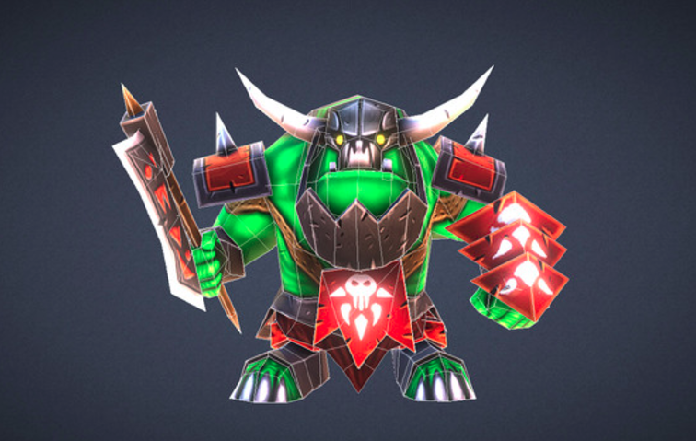

**Leve 4 (Boss):** 15 regular kills (60 points), 4 headshot (100 points), 2 staff attacks (100 points)

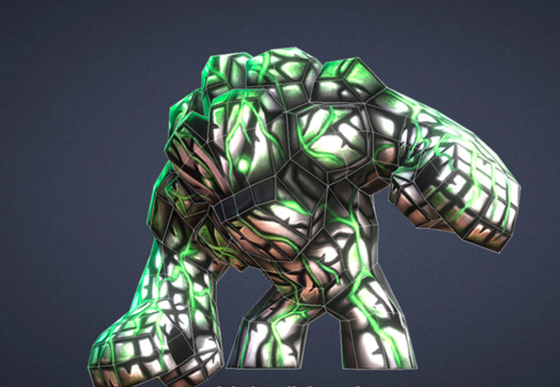

Traps/Bonus:

**Barrels:** Activate after 1 regular shot, explode within certain distance.

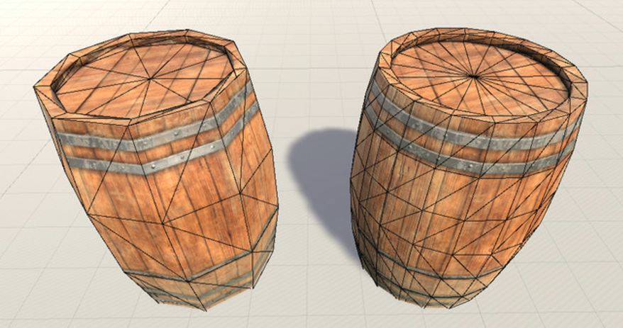

**Power Up Particles:** Activate after 1 regular shot, emit after enemy being killed.

